1️⃣ How parameter passing REALLY works in Java (core truth)
Golden rule (must remember)
Java is ALWAYS pass-by-value.
There is no true pass-by-reference in Java

Two categories of values in Java
🔹 Primitive values
- int, float, double, char, etc.
- Actual value is copied
🔹 Reference values
- Object references
- The reference (address) is copied, not the object

2️⃣ Pass-by-value with primitives (clear meaning)
Definition
Pass by value means the method receives a copy of the caller’s value, and the caller’s variable itself can never be changed by the method.
If a method could change the caller’s variable itself, then it cannot be said as pass by value
In Java this is almost impossible because a method NEVER changes the caller’s variable itself.

3️⃣ Case 1: Primitive variables (int, float, etc.)
Value = actual data
int a = 10;
Value stored in a → 10
When passed to a method:
- A copy of 10 is passed
- Method works on its own copy
Result
✔ Changes inside method do not affect caller
✔ This is pass by value
Eg: Pass_By_Value_Primitive
Explanation
- a and x are different variables
- They live in different stack frames
- Memory of a is never changed

4️⃣ Case 2: Object variables (references)
Pass by reference means:
the caller’s variable itself is passed (or an alias to it),
so any reassignment done inside the method is reflected in the caller.

Pass by reference is not supported in Java because a method never receives the caller’s variable itself.
Java passes a copy of the value (including reference values), so reassignment inside the method is not reflected in the caller.

Eg: Object_Reference_Passing

Why change is visible?
- f1 and obj refer to the same object
- The reference is copied, but both point to the same memory

❗ Important clarification (very important)
Java does NOT pass objects by reference.
It passes references by value.
That is why:
- Object data can change
- Reference reassignment does NOT affect caller

Proof: reference reassignment does NOT work
static void modify(Fizz obj) {
obj = new Fizz(); // reassigns local copy only
}
Caller object remains unchanged.

4️⃣ final with references
final applies to the reference variable, not to the object.
This means:
- You cannot change what the reference points to
- You can change the data inside the object

What final Fizz f = new Fizz(); REALLY means
final Fizz f = new Fizz();
This does NOT mean:
❌ “No new Fizz object can ever be created”
It means:
✅ “The reference variable f can never point to a different object”

Why this line is allowed
f.x = 10; // allowed
Because:
- You are not changing the reference f
- You are modifying the object’s internal state
- final does not protect object data

Why this line is NOT allowed
f = new Fizz(); // NOT allowed
Because:
- This tries to change the reference
- f was declared final
- Reassignment is forbidden

Very important clarification (your exact doubt)
❓ “You are saying f cannot be used again, but a new Fizz object can be created?”
✅ Correct understanding
- f cannot be reassigned
- But new Fizz objects can absolutely be created
- They just cannot be assigned to f
Example:
final Fizz f = new Fizz();

Fizz f2 = new Fizz(); // perfectly allowed
Fizz f3 = new Fizz(); // perfectly allowed

f2 = f3; // allowed (f2 is not final)
Only this is illegal:
f = f2; // NOT allowed

One-line perfect note (write this)
final on a reference variable prevents reassignment of the reference, not creation or modification of objects.

5️⃣ Why Java does not support true pass-by-reference
Design reasons
- Prevents pointer misuse
- Improves security
- Avoids memory corruption
- Keeps JVM safe and portable

6️⃣ Techniques that appear like pass-by-reference
These do NOT change Java’s rule, but achieve shared modification.
✔ Technique 1: Modify object state
Eg: Modify_Object_State

✔ Technique 2: Return updated value
Eg: Return_value

✔ Technique 3: Single-element array
Eg: Single_Element_Array

7️⃣ Static vs instance data (clean explanation)
When to use static variable
If data is common to all objects, make it static.
When to use instance variable
If data is object-specific, keep it non-static.

Eg: Farmer_Loan
Explanation
- rate → same for all farmers → static
- principal, time → farmer specific → instance variables

8️⃣ Static vs instance methods (correct meaning)
Static methods
- Object independent
- Operate on static data
- Also called generic methods
Instance methods
- Object dependent
- Operate on instance data
- Also called specific methods

✅ What happens with the given code?
Code inside class A (important parts)
public class A {

private int counter = 0; // instance variable

public static int getInstanceCount() {
return counter; // ❌ illegal access
}

public A() {
counter++;
}
}

🔴 Why this causes a compilation error
Key rule (very important)
A static method cannot access instance variables directly.
Reason
- counter is an instance variable
- Instance variables belong to objects
- getInstanceCount() is static
- Static methods belong to the class, not to any object
- At the time a static method is called, no object may exist
So this line is illegal:
return counter;

❌ Compile-time error (conceptually)
non-static variable counter cannot be referenced from a static context
Therefore:
- The program does not compile
- No runtime output is produced

✅ So the given answer is CORRECT
✔ Instance variable counter cannot be accessed in static method getInstanceCount()
✔ This leads to a compilation error

Eg: Static_Method_Eg2
// go through the code

Eg: Gamma
// go through the code
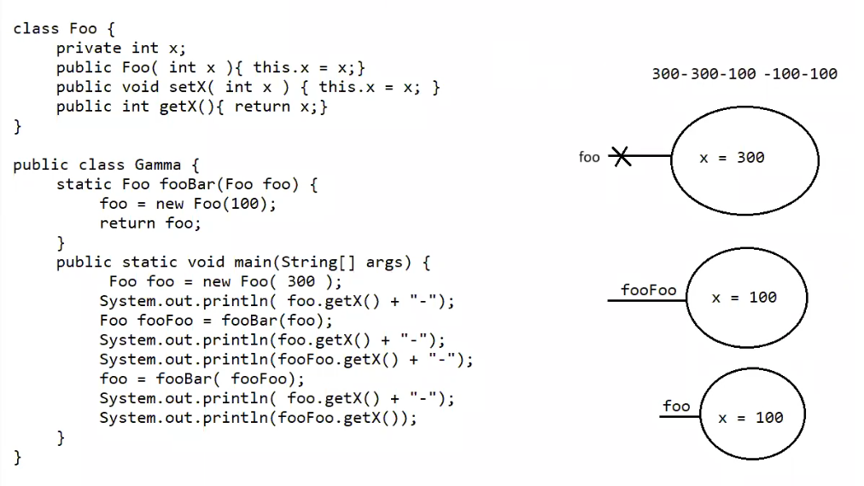

Eg: Static_Block_Eg5
// go through the code

